Spine & Hinge Creaser

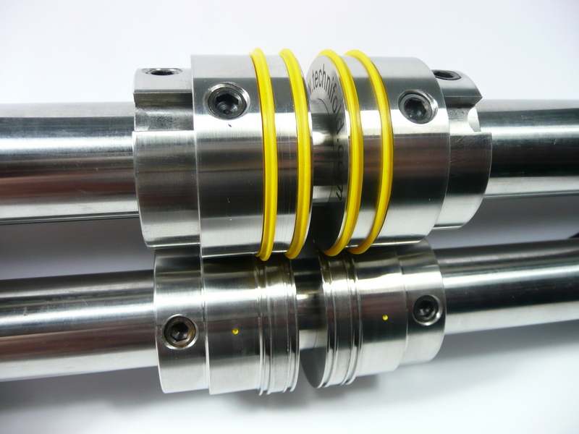
Crease rib holding collar
Shaft fixing screw
B
A

Each of the 4 crease units must be placed in the correct order as shown above.

Setting the Spine & Hinge creaser
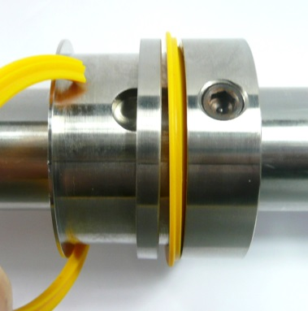
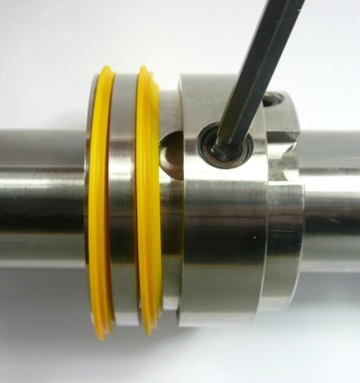

When changing from one stock weight to another you may need to change to another creasing ri. The design of the rib makes it quick and easy to do this.

Firstly lift open the shaft cover and use the 4mm Allen key to loosen the shaft fixing screw on the creasing rib holder (see picture above).

Adjust the thickness of the spine by loosening the 4 shaft fixings screws A and slide the 4 components apart until the correct spine is achieved.
To move an individual crease rib holder, use a finger or thumb to lift the calliper adjustment plate upwards. The creasing rib holder will now slide freely along the shaft. The crease ribs have a wedge shape on one edge and a flat side on the opposite side, It is important to place the flat edge on the side nearest the spine
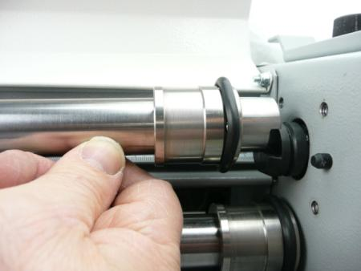
Shaft holder

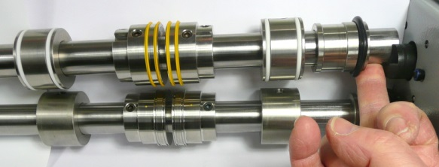

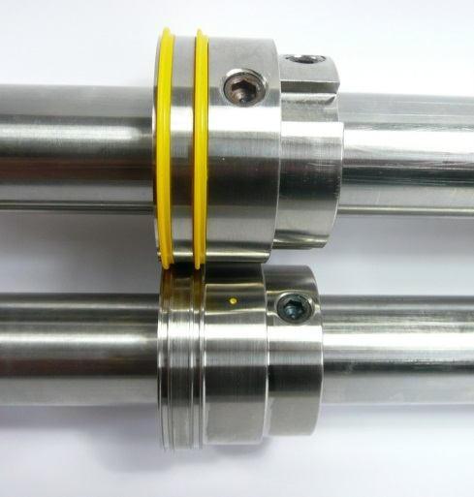
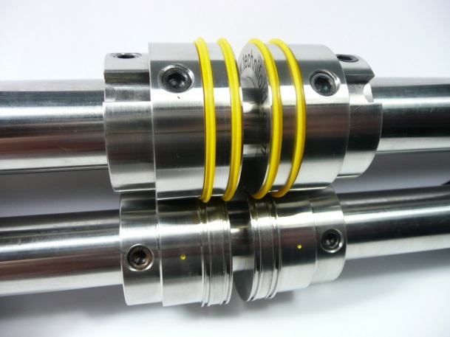

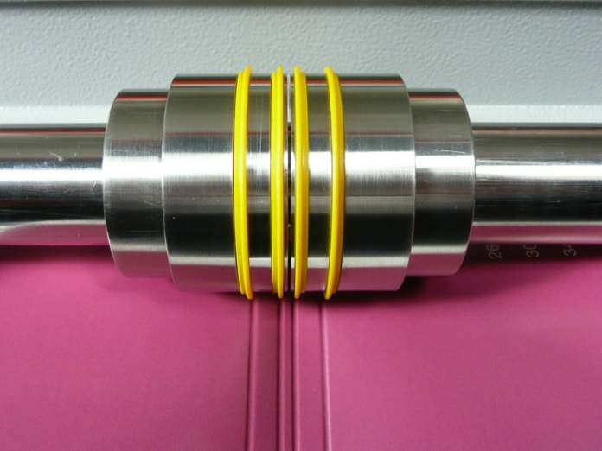
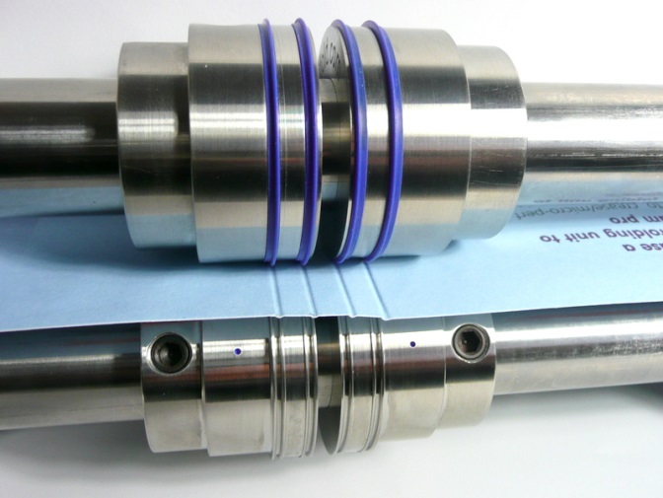

The minimum spine thickness is 3mm
Yellow settings for paper stocks 250-350gsm
Blue settings for paper stocks 200- 300gsm

Once your crease position has been identified, tighten the fixing screws on the
bottom shaft.

Advance a sample sheet through the machine until the sheet has rotated at least 360 degrees and the fixing ring screws are visible.

Once the feed guides and creasers are positioned correctly, take a single sheet of
paper and place it down between the guides. The sheet will automatically align itself
and move towards the adjuster feed tower and then switch the machine on. The
sheet will slowly feed through the callipers, if any doubles occur please slowly tighten
the central adjuster as follows.

